|  |  |  |
| --- | --- | --- |
|  |  |  |

**Cheryl Sensenbrenner call in date**

May 12, 2015 from 2:00 PM to 3:00 PM ET

**Disability Matters with Joyce Bender will be hosting a call for Cheryl Sensenbrenner and her friends, family, Congressional Leaders and well-wishers. Call in and tell her how you miss her and wish for her recovery. Tell her friends.**

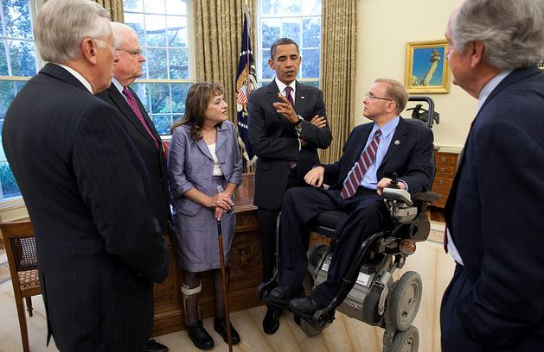



For Guests to speak please email Joyce Bender at choward@benderconsult.com

or Madonna Long at MadonnaLong@gmail.com.

As you all know the Amazing & Lovely Cheryl Sensenbrenner last year had a brain aneurysm. She is recovering very well and she needs to hear from you. Jim and all her friends are asking you to call in!!

**LET’S DO THIS!!!**

Call in, tell her how much you miss her. She will be listening and responding back.

Tuesday, May 12, 2015 and the show runs from 2:00 PM to 3:00 PM ET. The number for people to call-in to the show is 1-866-472-5788. If Cheryl touched your life then let’s touch hers back.

